In this week I worked on my main responsibility, the development of the detection subsystem. The main responsibility of this subsystem is the detection of the surrounding objects and quantization of this data. Since the main challenge of this project is data transfer between robot and telecontroller, we need to reduce the amount of the transferred data. By processing the image, we can effectively shrink the data. To reach out this objective this week;

* I wrote a RGB to HSV color transformation with only the basic functions of MATLAB. This transformation makes our image processing more reliable and adaptable for environmental color change.
* After then, I started to write a color detection algorithm which separate specific color object from the overall system. With this method we can separate the important objects from the environment noise. This helps our shape detection algorithm to detect objects in shorter process time. The result of this function can be observed in Figure 5

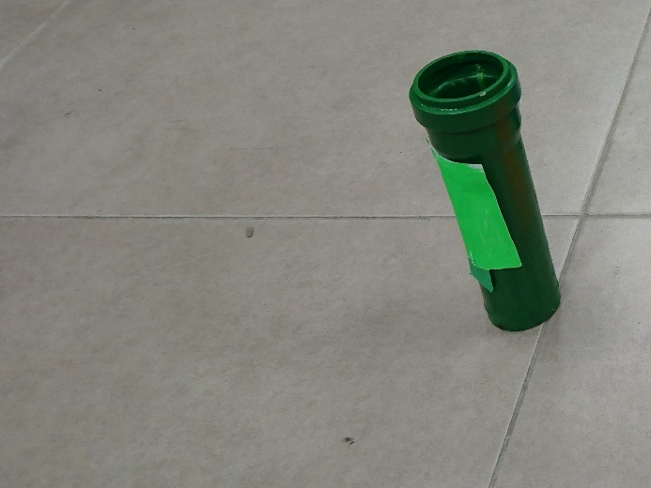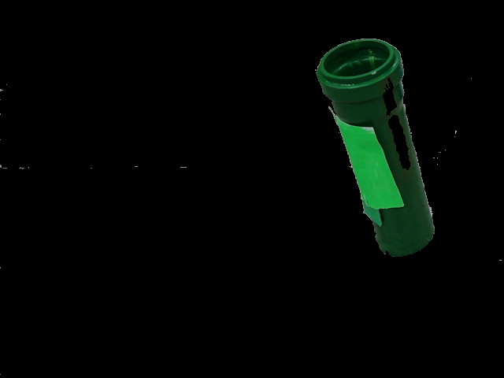

Figure 1: Raw image (left) and its Hue filtered version (right)